**Divide-Questions**

Key Stage 3: 2003 Paper 1 Level 3-5

1.

2.

3.

4.

Key Stage 3: 2003 Paper 1 level 4-6

5.

6.

Key Stage 3: 2004 Paper 1 Level 3-5

7.

8.

9.

10.

Key Stage 3: 2004 Paper 2 Level 3-5

11.

Key Stage 3: 2004 Paper 1 Level 4-6

12.

13.

Key Stage 3: 2005 Paper 1 Level 3-5

14.

Key Stage 3: 2005 Paper 2 Level 3-5

15.

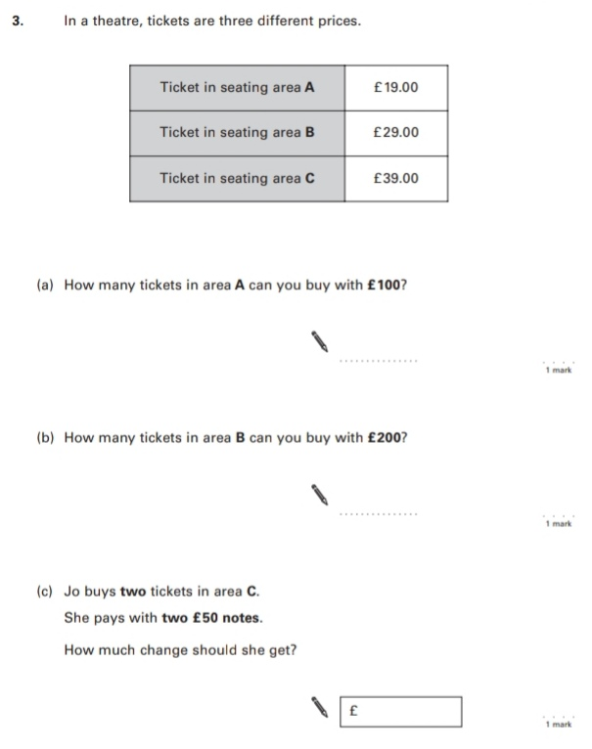

16.

17.

18.

Key Stage 3: 2005 Paper 1 Level 4-6

19.

Key Stage 3: 2005 Paper 2 Level 4-6

20.

21.

Key Stage 3: 2006 Paper 1 Level 3-5

22.

23.

Key Stage 3: 2006 Paper 2 Level 3-5

24.

25.

Key Stage 3: 2006 Paper 1 Level 4-6

26.

27.

Key Stage 3: 2006 Paper 2 Level 4-6

28.

29.

Key Stage 3: 2007 Paper 1 Level 3-5

30.

Key Stage 3: 2007 Paper 2 Level 3-5

31.

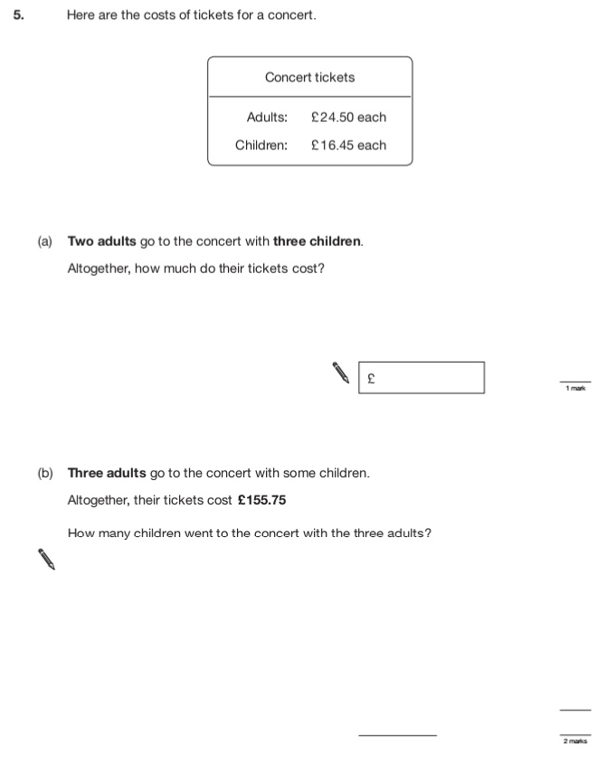

32.

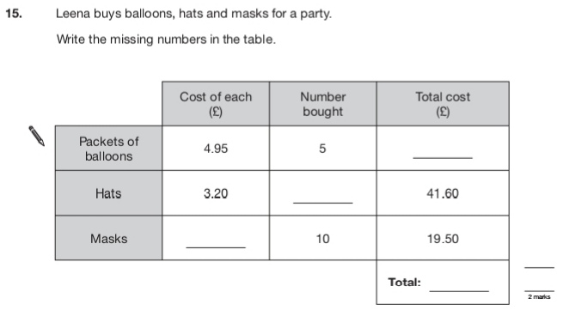

33.

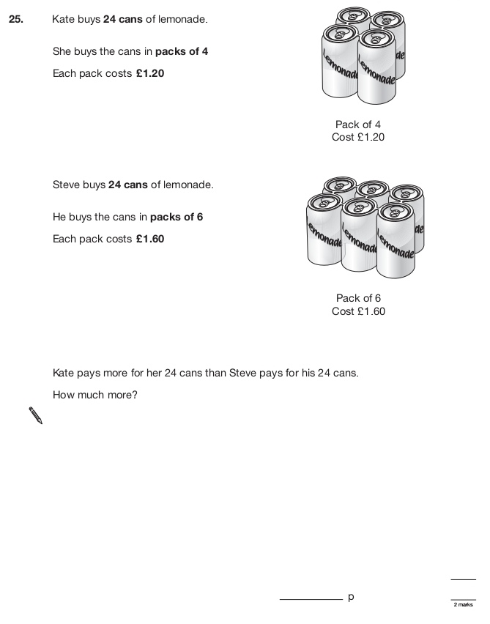

Key Stage 3: 2007 Paper 2 Level 4-6

34.

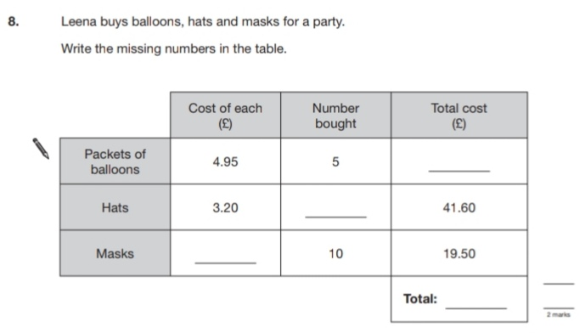

35.

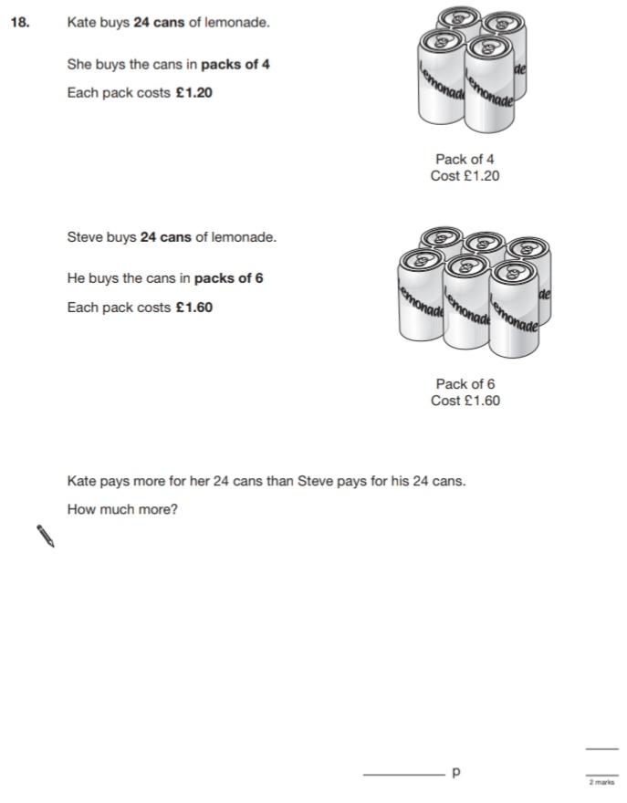

Key Stage 3: 2008 Paper 1 Level 3-5

36.

37.

38.

Key Stage 3: 2008 Paper 1 Level 4-6

39.

40.

Key Stage 3: 2009 Paper 1 Level 3-5

41.

42.

Key Stage 3: 2009 Paper 2 Level 3-5

43.

Key Stage 3: 2009 Paper 1 Level 4-6

44.

Key Stage 3: 2010 Paper 1 Level 3-5

45.

46.

Key Stage 3: 2010 Paper 2 Level 3-5

47.

Key Stage 3: 2010 Paper 1 Level 4-6

48.

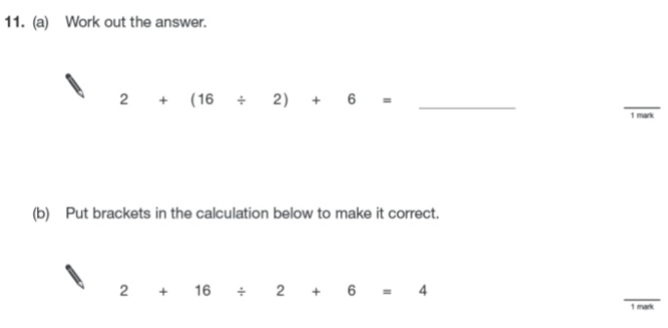

Key Stage 3: 2010 Paper 2 Level 4-6

49.

50.

Key Stage 3: 2011 Paper 2 Level 4-6

51.

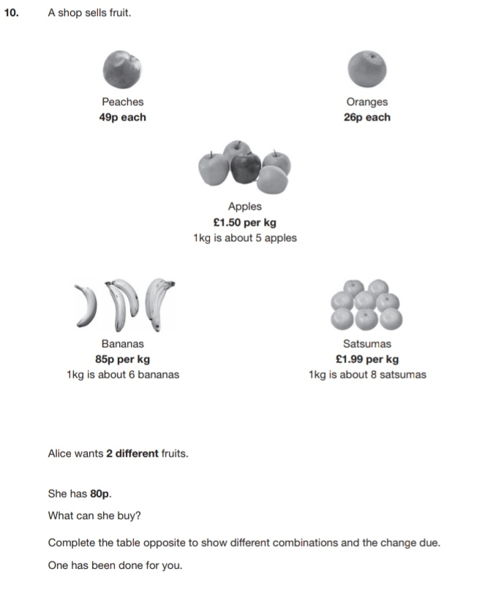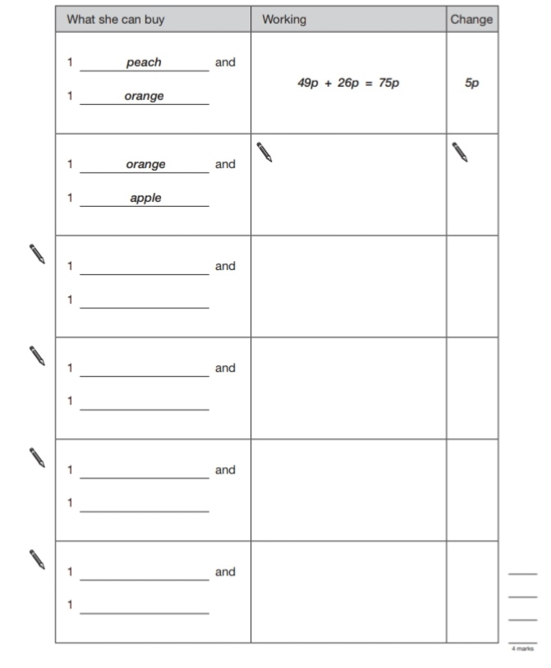

52.

